Task 1: Behavioral Cloning using NVIDIA PilotNet

1. Introduction
The objective of this task was to implement the NVIDIA PilotNet architecture for behavioral cloning using PyTorch. Unlike a classification problem, behavioral cloning is a regression task where the model predicts a continuous steering angle directly from dashboard camera images.
The model learns the relationship between road images and corresponding steering commands. Such end-to-end learning approaches are commonly used in autonomous driving systems because they eliminate the need for manually designed lane detection and path planning pipelines.

2. Dataset
The CARLA Steering Dataset was used for this task.
The dataset contains:
- Front-facing camera images collected from a simulated driving environment.
- Corresponding steering angle values stored in a text file.
- Approximately 86,491 image-steering pairs.
Each image was paired with its corresponding steering value to create the training samples.

3. Data Preprocessing
The following preprocessing steps were performed:
- Images were loaded using the Python Imaging Library (PIL).
- Images were resized to 200 × 66 pixels, matching the dimensions used in the original PilotNet architecture.
- Images were converted to PyTorch tensors.
- Steering values were converted into floating-point tensors.
- The dataset was divided into:
  - 80% Training Set
  - 20% Validation Set
DataLoaders were created using a batch size of 64.

4. Model Architecture
The PilotNet architecture was implemented from scratch using PyTorch without relying on any pre-built torchvision models.
Feature Extraction Layers
Layer | Configuration
Conv1 | 3 → 24, Kernel 5×5, Stride 2
ReLU | Activation
Conv2 | 24 → 36, Kernel 5×5, Stride 2
ReLU | Activation
Conv3 | 36 → 48, Kernel 5×5, Stride 2
ReLU | Activation
Conv4 | 48 → 64, Kernel 3×3
ReLU | Activation
Conv5 | 64 → 64, Kernel 3×3
ReLU | Activation
Fully Connected Layers
Layer | Configuration
FC1 | 1152 → 100
ReLU | Activation
FC2 | 100 → 50
ReLU | Activation
FC3 | 50 → 10
ReLU | Activation
FC4 | 10 → 1
The final layer outputs a single continuous steering value.

5. Training Procedure
The model was trained using:
- Loss Function: Mean Squared Error (MSE Loss)
- Optimizer: Adam Optimizer
- Batch Size: 64
- Epochs: 3
During training:
- Images were passed through the network.
- Predicted steering angles were generated.
- Mean Squared Error was computed.
- Backpropagation updated network weights.
- Validation loss was calculated after every epoch.

6. Training Results
The model converged successfully during training.
Epoch | Training Loss | Validation Loss
1 | 0.006129 | 0.004028
2 | 0.003060 | 0.002463
3 | 0.002105 | 0.001881
The losses decreased consistently across epochs, indicating effective learning and good generalization performance.

7. Loss Curve Analysis
A training-versus-validation loss graph was generated.
Observations:
- Training loss decreased steadily.
- Validation loss also decreased steadily.
- No significant overfitting was observed.
- The model demonstrated stable convergence.
The similarity between training and validation losses suggests that the network generalized well to unseen data.
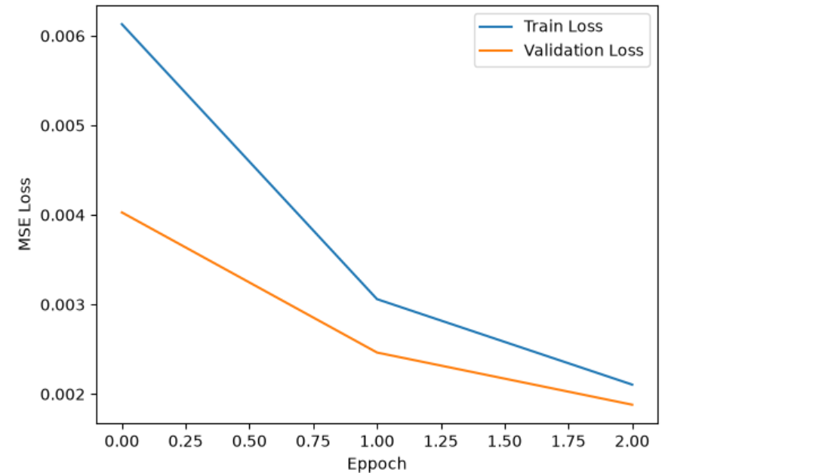

8. Sample Predictions
The trained model was evaluated on validation images.
Predicted steering values were compared against ground truth steering values. In most cases, the predicted steering angles closely matched the actual steering commands, demonstrating successful learning of driving behavior.
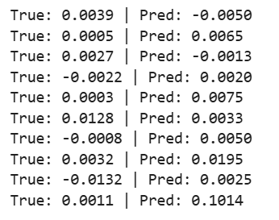

9. Discussion
Behavioral cloning differs from image classification because the output is a continuous numerical value rather than a discrete class label.

Key challenges included:
- Handling a large dataset.
- Training on CPU resources.
- Understanding regression-based loss functions.
- Correctly matching image data with steering labels.
The PilotNet architecture proved effective for predicting steering angles directly from raw image inputs.

10. Conclusion
In this task, the NVIDIA PilotNet architecture was successfully implemented from scratch using PyTorch. The model was trained on the CARLA Steering Dataset and learned to predict steering angles directly from dashboard camera images.
The training and validation losses consistently decreased, demonstrating successful learning. The project provided practical experience in:
- Building convolutional neural networks from scratch.
- Working with regression problems.
- Processing image datasets.
- Implementing end-to-end autonomous driving pipelines.
Overall, the task successfully demonstrated the application of deep learning techniques to behavioral cloning for self-driving cars.

References
- NVIDIA, End to End Learning for Self-Driving Cars, 2016.
- PyTorch Documentation.
- CARLA Simulator Documentation.
- Course and assignment resources provided by Avrera.

AI Assistance
AI tools were used during this project for debugging, report making, resolving implementation errors, and improving the overall machine learning workflow.

